ЮУрГУ
Кафедра автоматики

Семестровое задание № 1
По электротехнике

Тема: «РАСЧЁТ РАЗВЕТВЛЁННОЙ ЦЕПИ ПОСТОЯННОГО ТОКА»

Выполнил: Храновский Г. гр. 226

Таблица числовых данных
 | IK1 | IK2 | IK3 | E4 | E5 | E6 | R1 | R2 | R3 | R4 | R5 | R6
 | A | A | A | B | B | B | Ом | Ом | Ом | Ом | Ом | Ом
23 | 0 | 1 | 2 | 0 | 11 | 8 | 5 | 3 | 4 | 5 | 0 | 4
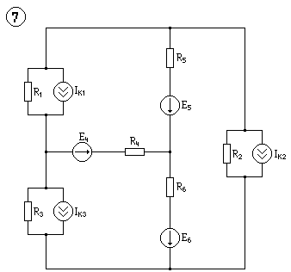
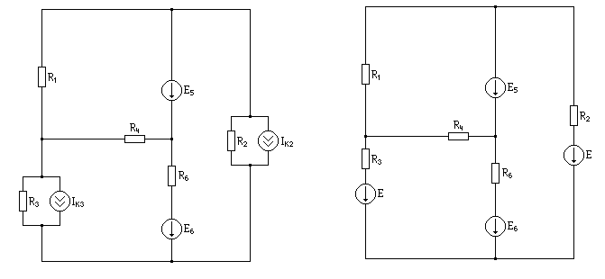
I₁₁
I₂₂

I₃₃
I₁
I₅
I₃
I₄
I₂

₂

I₆
₃

E=IR E₃=8В E₂=3В

Метод контурных токов

$$\begin{aligned}Ι_{\text{11}}(R_{1}+R_{4})−I_{\text{22}}R_{4}=E_{5} \\ I_{\text{22}}(R_{3}+R_{4}+R_{6})−I_{\text{11}}R_{4}−I_{\text{33}}R_{6}=E_{6}−E_{3} \\ I_{\text{33}}(R_{2}+R_{6})−I_{\text{22}}R_{6}=E_{2}−E_{6}−E_{5} \\ \\ Δ=R=\left[\begin{matrix}\text{10} & −5 & 0 \\ −5 & \text{13} & −4 \\ 0 & −4 & 7\end{matrix}\right]=\text{910}−\text{160}−\text{175}=\text{575} \\ \\ E=\left[\begin{matrix}\text{11} \\ 0 \\ −\text{16}\end{matrix}\right];{\text{ I}}_{\text{11}}={\text{0,878 I}}_{\text{22}}={\text{-0,443 I}}_{\text{33}}=\text{-2,539} \\ \\ Δ_{\text{11}}=\left[\begin{matrix}\text{11} & \text{-5} & 0 \\ 0 & \text{13} & −4 \\ \text{-16} & \text{-4} & 7\end{matrix}\right]=\text{1001}−\text{320}−\text{176}=\text{505} \\ \\ Δ_{\text{22}}=\left[\begin{matrix}\text{10} & \text{11} & 0 \\ −5 & 0 & −4 \\ 0 & −\text{16} & 7\end{matrix}\right]=\text{140}−\text{640}+\text{385}=−\text{255} \\ \\ Δ_{\text{33}}=\left[\begin{matrix}\text{10} & −5 & \text{11} \\ −5 & \text{13} & 0 \\ 0 & −4 & −\text{16}\end{matrix}\right]=−\text{2080}+\text{220}+\text{400}=−\text{1460} \\ \\ I_{1}={\text{-I}}_{\text{11 }}{\text{ I}}_{2}={\text{-I}}_{\text{33}}{\text{ I}}_{3}={\text{-I}}_{\text{22}}{\text{ I}}_{4}=I_{\text{22}}{\text{-I}}_{\text{11}}{\text{ I}}_{5}=I_{\text{11}}{\text{-I}}_{\text{33}}{\text{ I}}_{6}=I_{\text{33}}{\text{-I}}_{\text{22}} \\ \\ I_{1}=−0,\text{878}{\text{ I}}_{2}={\text{2,539 I}}_{3}={\text{0,443 I}}_{4}={\text{-1,321 I}}_{5}={\text{3,417 I}}_{6}=\text{-2,096}\end{aligned}$$

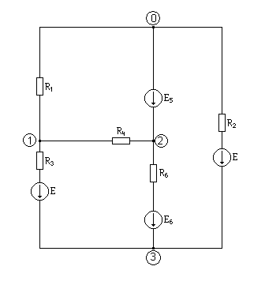
Метод узловых потенциалов
I₁
I₅
I₃
I₄
I₂
I₆

$$\begin{aligned}\text{Пусть }ϕ_{0}=0,\text{ то }ϕ_{2}=E_{5}=\text{11} \\ \\ \left\{\begin{matrix}\begin{aligned}ϕ_{1}\left(\frac{1}{R_{1}}+\frac{1}{R_{4}}+\frac{1}{R_{3}}\right)−ϕ_{2}\frac{1}{R_{4}}−ϕ_{3}\frac{1}{R_{3}}=−\frac{E_{3}}{R_{3}} \\ \end{aligned} \\ ϕ_{3}\left(\frac{1}{R_{3}}+\frac{1}{R_{6}}+\frac{1}{R_{2}}\right)−ϕ_{1}\frac{1}{R_{3}}−ϕ_{2}\frac{1}{R_{6}}=\frac{E_{3}}{R_{3}}+\frac{E_{6}}{R_{6}}+\frac{E_{2}}{R_{2}}\end{matrix}\right. \\ \end{aligned}$$

$$\begin{aligned}\left\{\begin{matrix}ϕ_{1}\left(\frac{1}{5}+\frac{1}{5}+\frac{1}{4}\right)−\frac{\text{11}}{5}−ϕ_{3}\frac{1}{4}=−\frac{8}{4} \\ ϕ_{3}\left(\frac{1}{4}+\frac{1}{4}+\frac{1}{3}\right)−ϕ_{1}\frac{1}{4}−\frac{\text{11}}{4}=\frac{8}{4}+\frac{8}{4}+\frac{3}{3}\end{matrix}\right. \\ \\ \left\{\begin{matrix}0,\text{65}ϕ_{1}−0,\text{25}ϕ_{3}=0,2 \\ 0,\text{833}ϕ_{3}−0,\text{25}ϕ_{1}=7,\text{75}\end{matrix}\right. \\ ϕ_{1}=\frac{0,\text{833}ϕ_{3}−7,\text{75}}{0,\text{25}} \\ 2,\text{1658}ϕ_{3}−0,\text{25}ϕ_{3}−\text{20},\text{15}=0,2 \\ \left\{\begin{matrix}ϕ_{3}=\text{10},\text{622} \\ ϕ_{1}=4,\text{393}\end{matrix}\right. \\ I_{1}=\frac{ϕ_{0}−ϕ_{1}}{R_{1}}{\text{ I}}_{3}=\frac{ϕ_{1}−ϕ_{3}+E_{3}}{R_{3}}{\text{ I}}_{5}=I_{2}−I_{1} \\ I_{2}=\frac{ϕ_{3}−ϕ_{0}−E_{2}}{R_{2}}{\text{ I}}_{4}=\frac{ϕ_{1}−ϕ_{2}}{R_{4}}\end{aligned}$$

$$\begin{aligned}I_{1}=\frac{−4\text{.}\text{393}}{5}=−0,\text{878}{\text{ I}}_{5}=\text{2,539}+\text{0,878}=\text{3,417} \\ I_{2}=\frac{\text{10}\text{.}\text{622}−3}{3}=2,\text{539}{\text{ I}}_{6}=\frac{\text{10},\text{622}−\text{11}−8}{4}=−2,\text{096} \\ I_{3}=\frac{4,\text{393}−\text{10},\text{622}+8}{4}=0,\text{443} \\ I_{4}=\frac{4,\text{393}−\text{11}}{5}=−1,\text{321}\end{aligned}$$

Проверка правильности решения по законам Кирхгофа

$\begin{aligned}I_{4}+I_{5}+I_{6}=0 \\ I_{1}−I_{4}−I_{3}=0 \\ I_{2}−I_{5}−I_{1}=0 \\ \\ I_{1}R_{1}+I_{4}R_{4}=−E_{5} \\ I_{6}R_{6}−I_{4}R_{4}+I_{3}R_{3}=E_{3}−E_{6} \\ I_{2}R_{2}−I_{6}R_{6}=−E_{2}+E_{5}+E_{6}\end{aligned}$ $\begin{aligned}−1,\text{321}+3,\text{417}−2,\text{096}=0 \\ −0,\text{878}+1,\text{321}−0,\text{443}=0 \\ 2,\text{539}−3,\text{417}+0,\text{878}=0 \\ \\ −0,\text{878}⋅5−1,\text{321}⋅5=−\text{11} \\ −2,\text{096}⋅4+1,\text{321}⋅5+0,\text{443}⋅4=0 \\ 2,\text{539}⋅3+2,\text{096}⋅4=\text{16}\end{aligned}$

$$\begin{aligned}\sum{P_{\text{ген}}=\sum{P_{\text{потр}}}} \\ \sum{P_{\text{ген}}}=−E_{2}I_{2}+E_{3}I_{3}+E_{5}I_{5}−E_{6}I_{3} \\ \sum{P_{\text{потр}}}=I_{1}R_{1}+I_{2}R_{2}+I_{3}R_{3}+I_{4}R_{4}+I_{6}R_{6} \end{aligned}$$

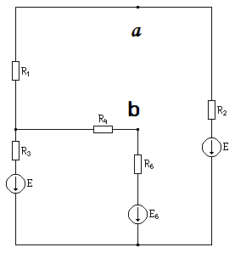

Считаем токи:
$$R=\left|\begin{matrix}{\text{ R}}_{3}+R_{4}+R_{6} & −(R_{6}+R_{4}) \\ −(R_{6}+R_{4}) & R_{1}+R_{2}+R_{4}+R_{6} \end{matrix}\right|$$

$$E=\left|\begin{matrix}{\text{-E}}_{3}+E_{6} \\ E_{2}\end{matrix}\right|$$
I=E·R⁻¹

I₃=-0.1929

I₁=-0.2786

I₆=$\left|\begin{matrix}−0,\text{1929} \\ −,\text{2786}\end{matrix}\right|=\text{0,0857}$
Потенциал а или b принимаешь за ноль, и находишь другой
b=0В
Потенциал м/у R₁ и R₃ равен R₄·I₆=0.4285
a= R₄·I₆+I₁·R₁=-0.536

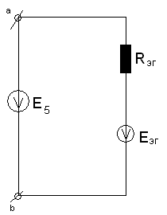
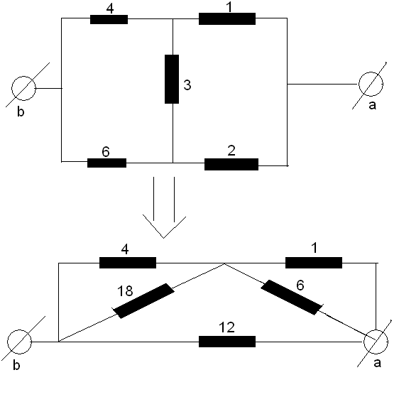

$$\begin{aligned}E_{\text{эг}}=0,\text{536}B \\ \text{Eэг}=ϕ_{b}−ϕ_{a}\end{aligned}$$

I₅=(E₅-E_{эг})/R_{эг}=3.4B
$$R_{\text{эг}}=\frac{\left(\frac{4⋅8}{\text{22}}+\frac{6}{7}\right)⋅\text{12}}{\frac{\text{72}}{\text{22}}+\frac{6}{7}+\text{12}}=3\text{.}\text{072}$$

Зависимость мощности P₅ на сопротивлении R₅
$$\begin{aligned}P_{5}=I_{5^{2}}⋅R_{5} \\ I_{5}=\frac{E_{5}−E_{\text{эг}}}{R_{\text{эг}}+R_{5}} \\ \\ 1\text{.}{\text{ R}}_{5}={\text{0,5 I}}_{5}=\frac{\text{10,464}}{\text{3,072}+\text{0,5}}=2,\text{929}{\text{ P}}_{5}=(\text{2,929})^{2}⋅0,5=4,\text{289} \\ 2\text{.}{\text{ R}}_{5}={\text{1 I}}_{5}=\frac{\text{10,464}}{\text{3,072}+1}=2,\text{569}{\text{ P}}_{5}=6,\text{599} \\ 3\text{.}{\text{ R}}_{5}={\text{1,5 I}}_{5}=2,\text{288}{\text{ P}}_{5}=7,\text{852} \\ 4\text{.}{\text{ R}}_{5}={\text{2 I}}_{5}=2,\text{063}{\text{ P}}_{5}=8,\text{5119} \\ 5\text{.}{\text{ R}}_{5}={\text{2,5 I}}_{5}=1,\text{877}{\text{ P}}_{5}=8,\text{807} \\ 6\text{.}{\text{ R}}_{5}={\text{3,072 I}}_{5}=1,\text{703}{\text{ P}}_{5}=8,\text{909} \\ 7\text{.}{\text{ R}}_{5}={\text{3,5 I}}_{5}=1,\text{592}{\text{ P}}_{5}=8,\text{8706} \\ 8\text{.}{\text{ R}}_{5}=4{\text{ I}}_{5}=1,\text{479}{\text{ P}}_{5}=8,\text{749}\end{aligned}$$

P₅
R₅

